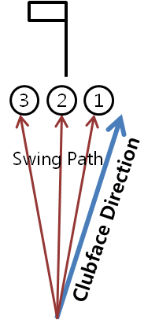**A Slice Cure**

If you are a player whose golf ball starts to the right and then slices further to the right while in flight, then there is no doubt, that at impact your clubface is open (pointing right of target), and also open relative to the direction of your swing (Swing Path).

You can be sure that your clubface is open, what you cannot be sure of is where your swing path is. It could be:

1. **Right of the target**. This will produce a shot that starts a little right of the target and then curves a little more right but probably not that bad, only a **Small** **Push Slice**.
2. **On Target**. A swing path on target, with a club face open to target will produce a ball that starts right and slices more to the right, a **Push Slice**.
3. **Left of target**. A swing path to the left, with a clubface open to the target will also produce a shot that starts to the right and curves further to the right, this will be a **Serve Push Slice.**

Please note that with all 3 of these, your clubface is open to the swing path, creating a **Push Slice**, just different amounts.

If you can learn to square your clubface in the downswing so that your clubface matches the path of your swing, you will be sure to stop the ball starting right, and the slicing further to the right. Try this feeling in your swing.

**Motor Bike (main pictures)**

* Place your left hand on the club as you normally would holding the club parallel to the ground in front of you.
* Now flex (flexion) your left down, the same way you would on a motorbike when you want to accelerate.
* Make your backswing as normal and to start your downswing flexing your wrist in the same way. This will be sure to close the clubface to your swing path fixing your open clubface.

Now that your clubface is not open you can start to understand where your swing path is:

* If you now have a draw shot your path was **right of the target**. Great!
* If you ball is now starting on line and flying straight then your swing path was good, **On Target**. Great!
* If your ball is now starting left and flying straight left then your swing path was to the **left of the target**, you will now need to learn to change your path more to the right. There could be a few reasons for this but the main fault I see for a swing path being to the left is the upper body starting the downswing. Take a look at Golf Digest Youtube’s Channel and you will find many drills to help you with this.